Monitor system usage for compliance

We use ManageEngine software to monitor all vms to check availability

Monitoring: IT Team check monitor everyday, If get any vm is down we start process to check reason for this

Logs:

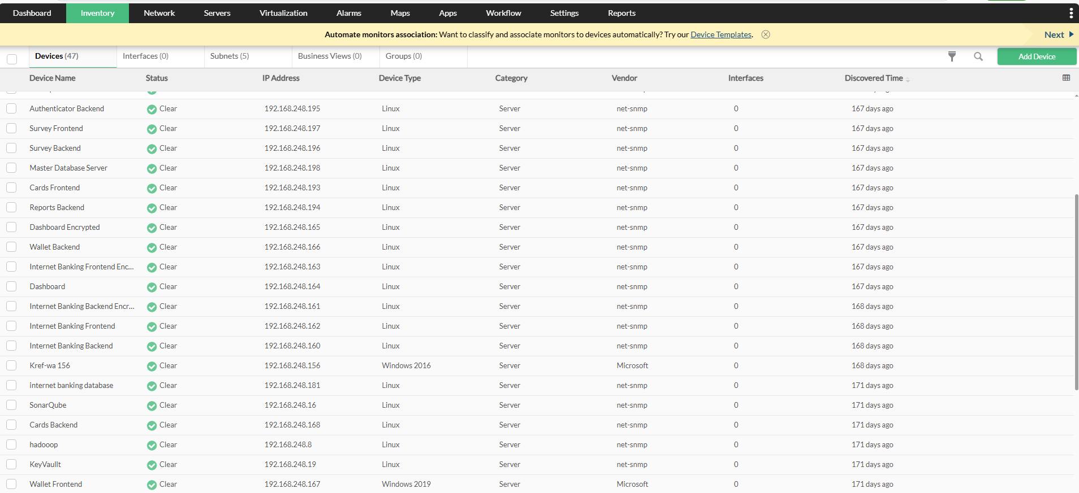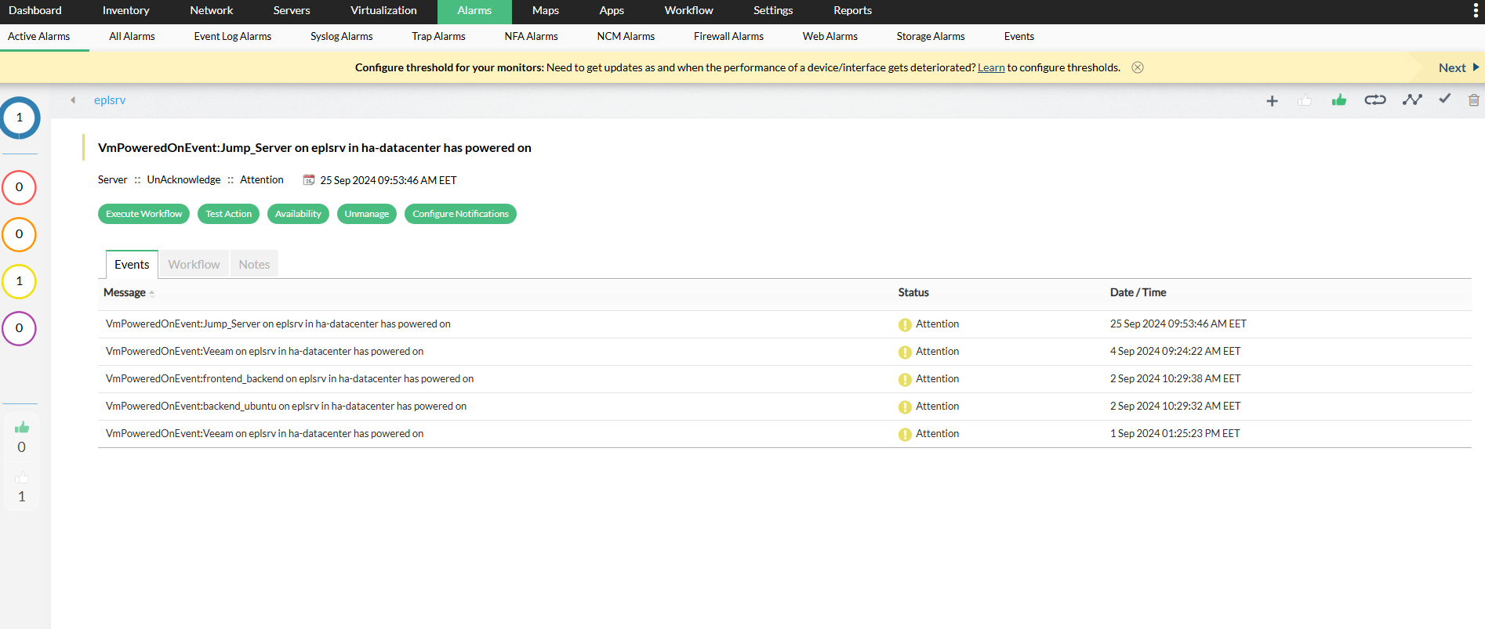

Monitoring & review ManageEngine is done by IT Team